### Exercise 4: Creating a Custom Connector for the Power BI Service API

In this exercise, you will create a custom connector to call the Power BI Service API. You will start by registering an application with Azure AD. Then you will create a custom connector in PowerApps that uses the Azure AD application to call the Power BI Service API.

1. Log into the Azure Portal
   1. In the browser, navigate to the Azure portal at <https://portal.azure.com>.
   2. When you are prompted to log in, provide the credentials to log in with your Office 365 user account name.
   3. Once you have logged into the Azure portal, check the email address in the login menu in the upper right to make sure you are logged in with the correct identity for your new Office 365 user account.

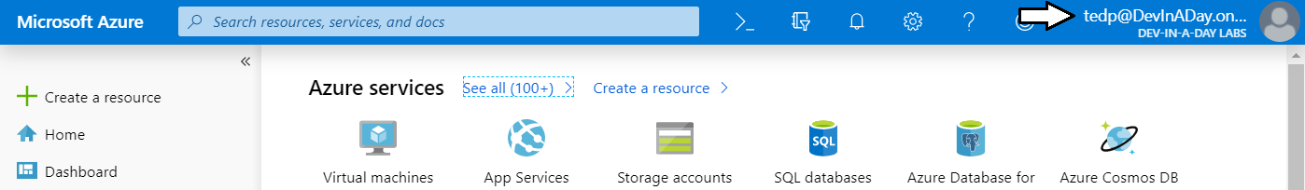

1. Register a new Azure AD application.
   1. In the left navigation, scroll down and click on the link for **Azure Active Directory**.
   2. Click the link for **App registration**.

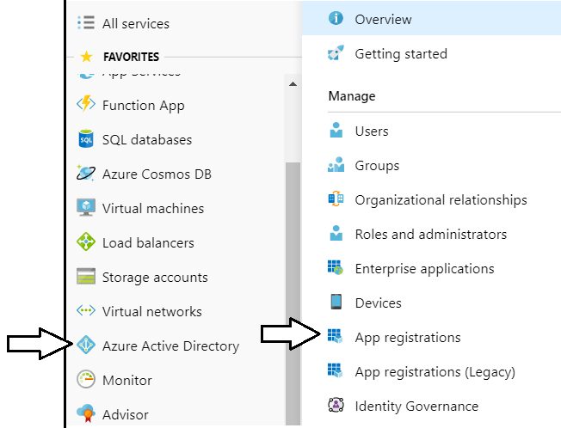

Note that the Azure portal user experience for creating and configuring Azure AD applications was updated in April 2019. If you start feeling nostalgic, you can get back to the old user experience by clicking the **App registrations (Legacy)** link.

* 1. Click **New registration**.

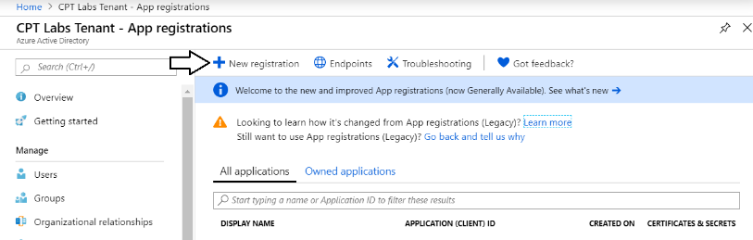

* 1. Enter a **Name** of **Custom Connector for Power BI**.

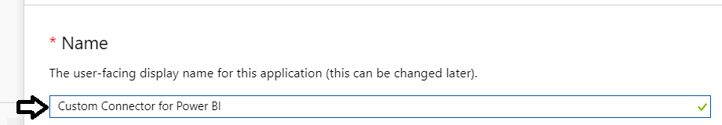

* 1. For the **Supported account types** option, leave the default value of **Accounts in this organizational directory only**.

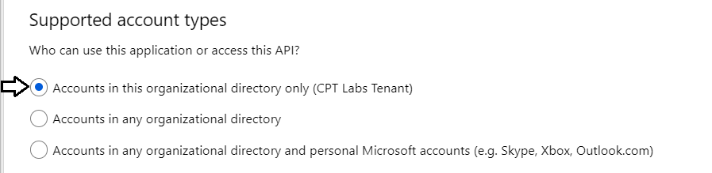

* 1. In the **Redirect URI** section, select **Web** in the left dropdown.
  2. In the textbox to the right, leave it empty as you will need to return and add this later in this lab exercise.
  3. Click the **Register** button to create the new Azure AD application.

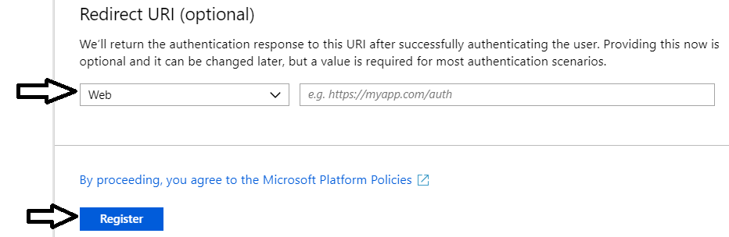

* 1. Once you've created the new application you should see the application summary view as shown in the following screenshot..

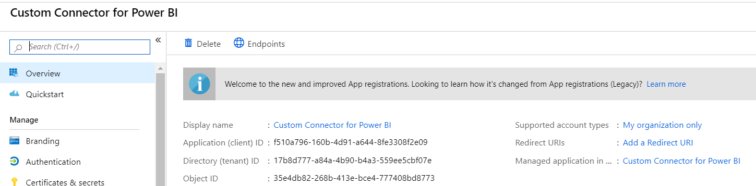

* 1. Copy the **Application ID** to the Windows clipboard.

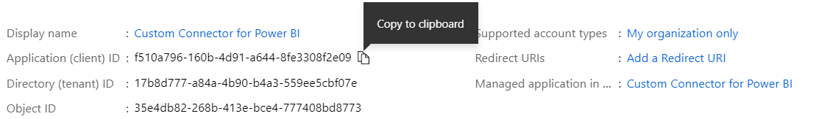

* 1. Launch Notepad and paste the **Application ID** into a new text file. Save the text file as **CustomConnectorInfo.txt**.

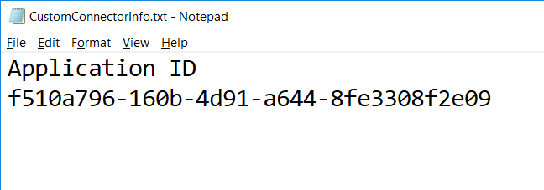

1. Configure required permissions for the Azure AD application.
   1. Click the **API permissions** link on the left.
   2. Click the **Add a permission** button in the **API permissions** section.

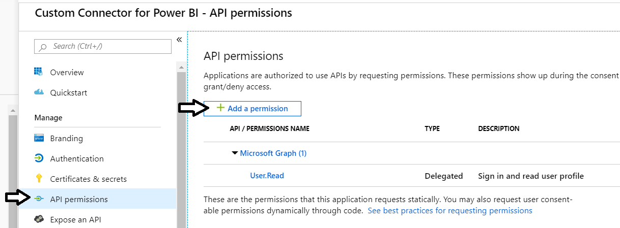

* 1. On the **Microsoft APIs** tab, click **Power BI Service**.

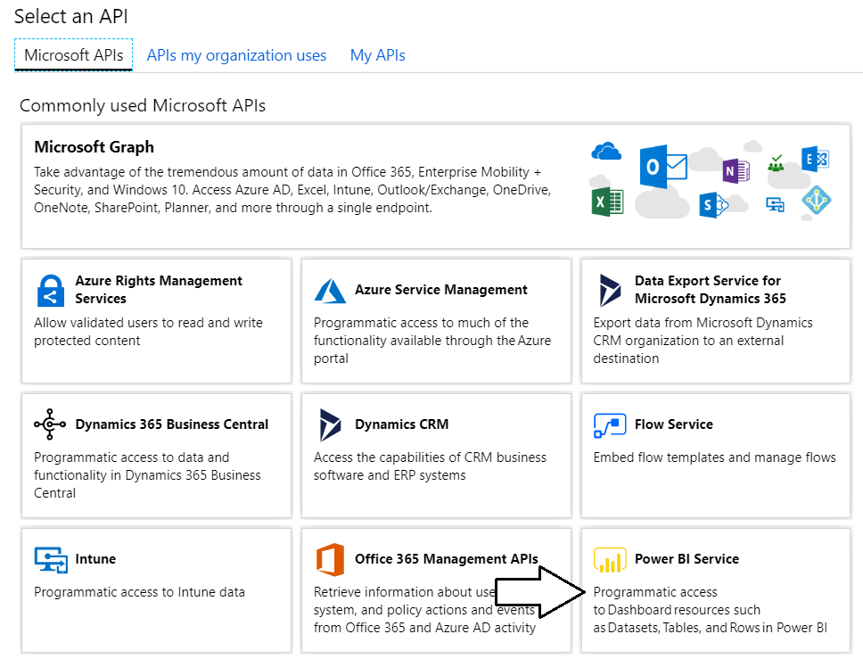

* 1. Click **Delegated Permissions**.

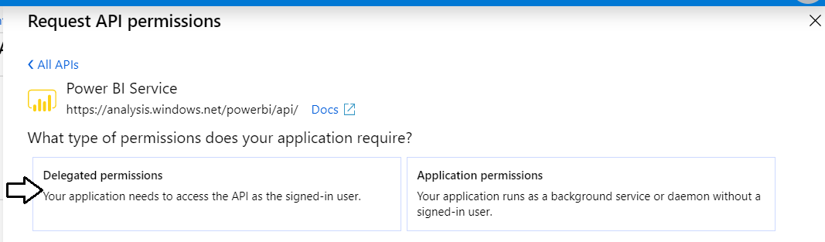

* 1. In the **PERMISSION** section, expand **Dataset** and select the **Dataset.ReadWrite.All** permission.

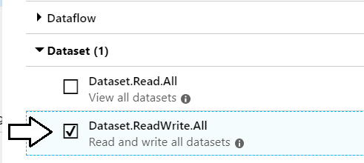

* 1. Expand **Group** and select the **Group.Read.All** permission.

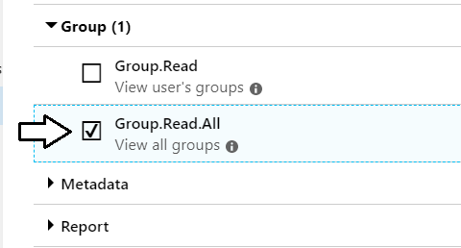

* 1. At this point, you should see that the Power BI Service permissions have been added to the **Required permissions** list.

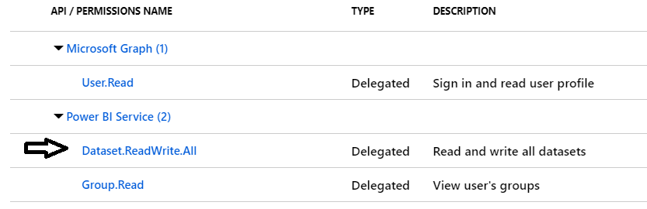

1. Create the application secret for the Azure AD application.
   1. Click **Certificates and secrets** in the left navigation and then click **New client secret**.

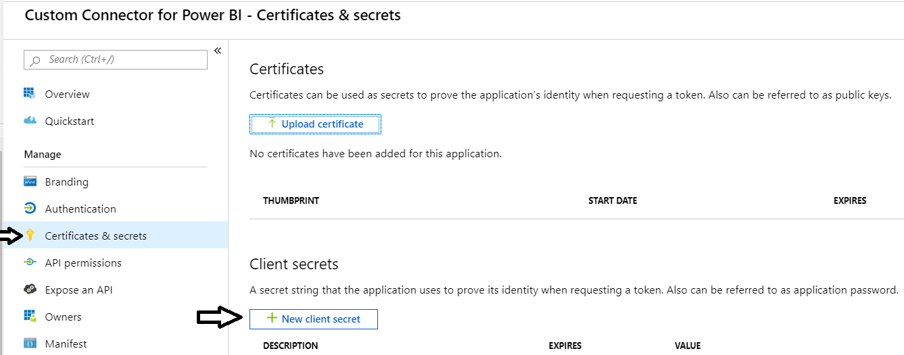

* 1. Add a **Description** of **Key1** and then click **Add**.

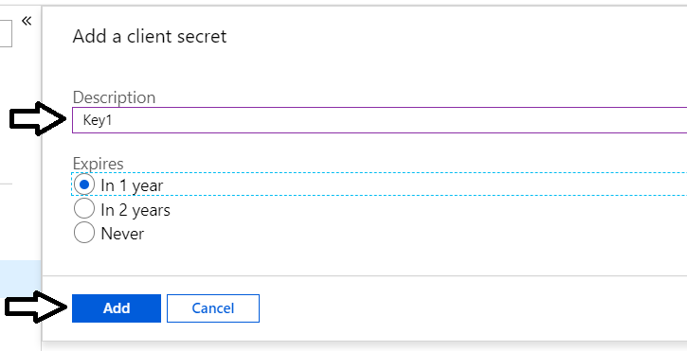

* 1. Once the new secret has been created, copy its value to the Windows clipboard.

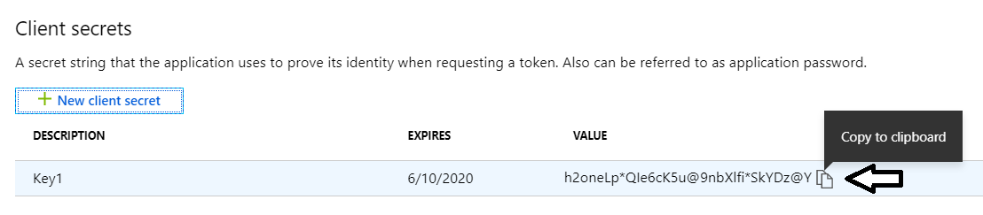

* 1. Copy the secret into the same text file that contains the Application ID.

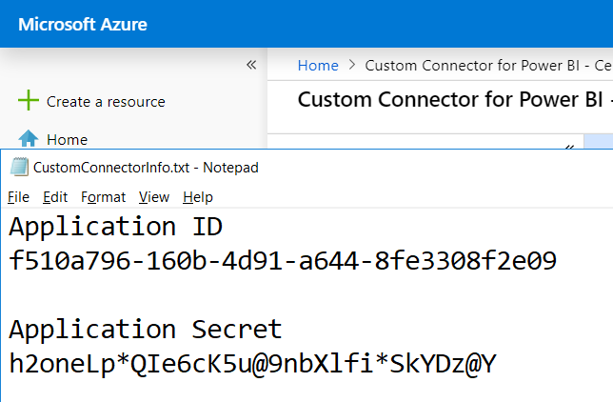

1. Create the custom connector in PowerApps.
   1. Locate the file in the ZIP archive download named **Power-BI-Datasets-API.swagger.json**.
   2. Navigate to the PowerApps Maker portal at <https://make.powerapps.com/home>.
   3. Navigate to the **Data > Custom Connectors** link.

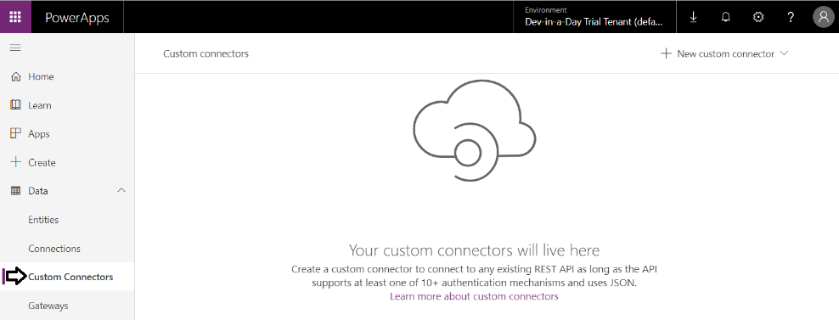

* 1. Click **New custom connector**.

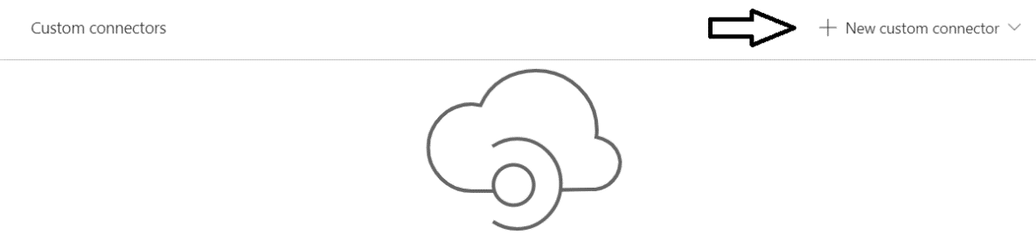

* 1. From the dropdown menu, click **Import an OpenAPI file**.

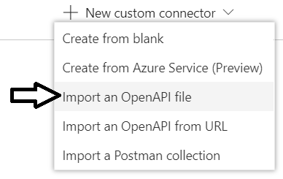

* 1. Type in a **Connector name** of **PowerBiDatasetsAPI** and then click **Import**.

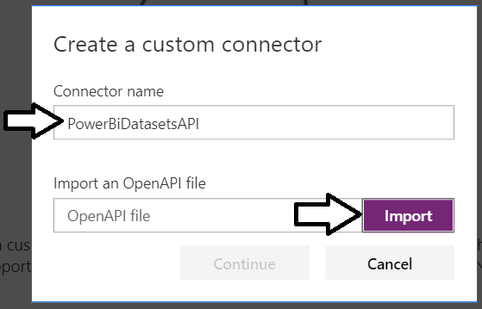

* 1. Select the file from the ZIP archive download named **Power-BI-Datasets-API.swagger.json** and click **Open**.

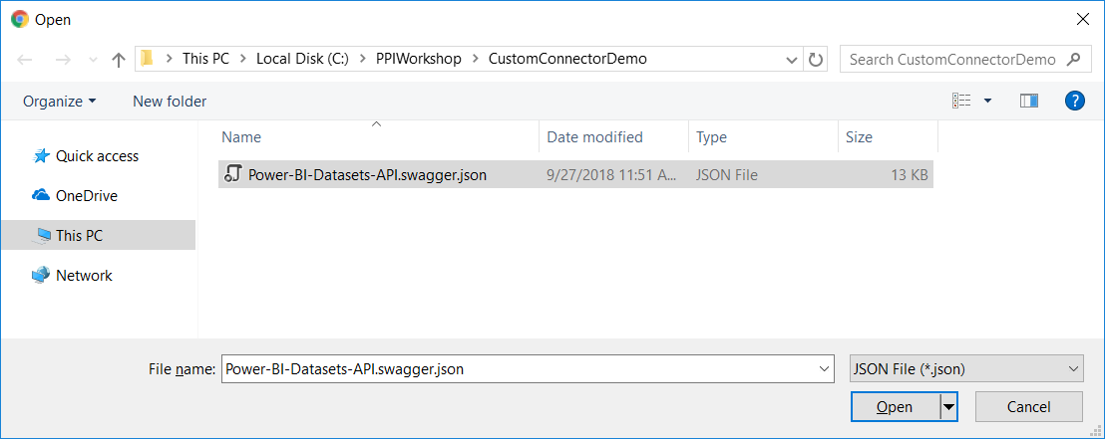

* 1. Click the **Continue** button to create the new custom connector.

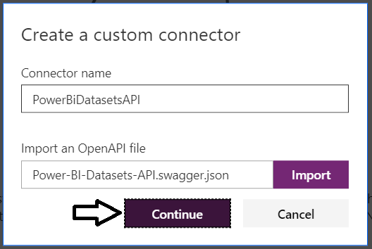

* 1. You should now see the **General** tab for the new custom connector.

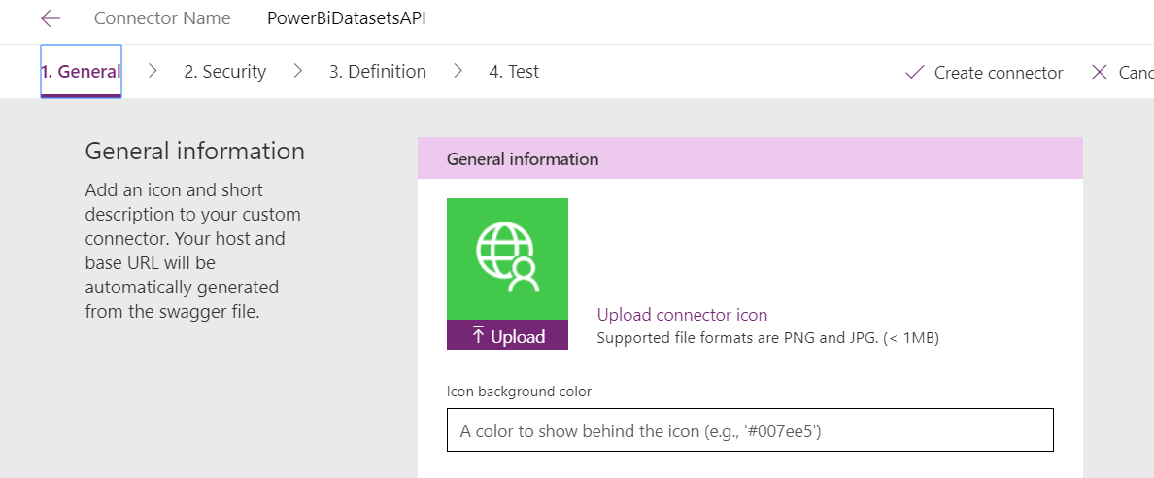

* 1. Click the Upload button to upload a custom icon.

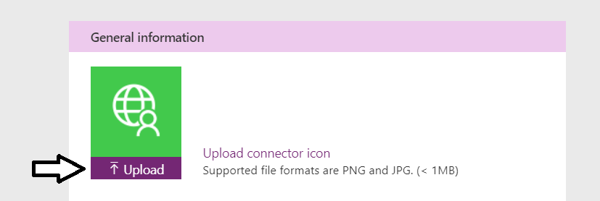

* 1. Select the file from the ZIP archive download named **AppIcon.png** and click **Open**.

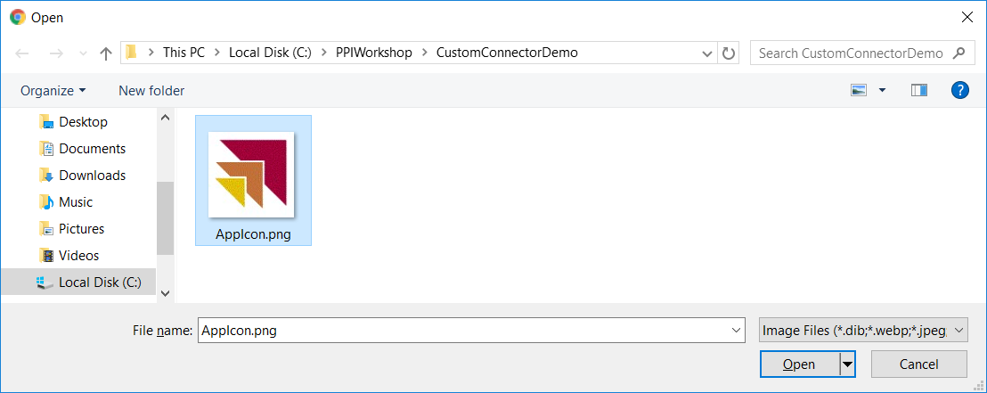

* 1. You should now see the custom icon.

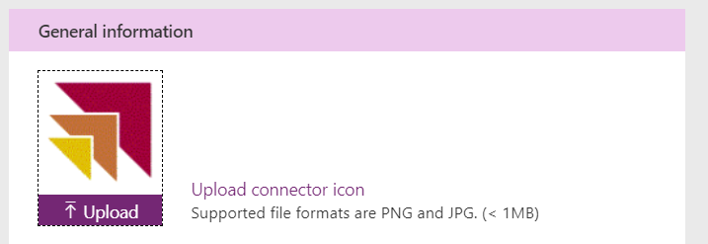

1. Configure security settings for the new custom connector.
   1. Click the **Security** to navigate to the Security tab

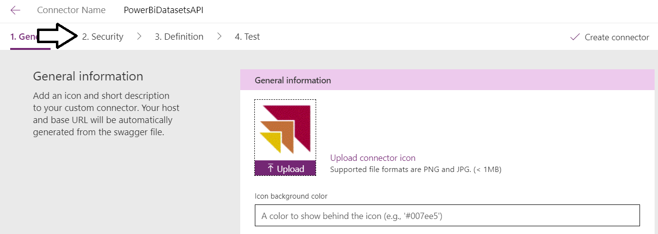

* 1. On the **Security** tab, notice that he **Client Id** value and the **Client secret** value need to be filled in.

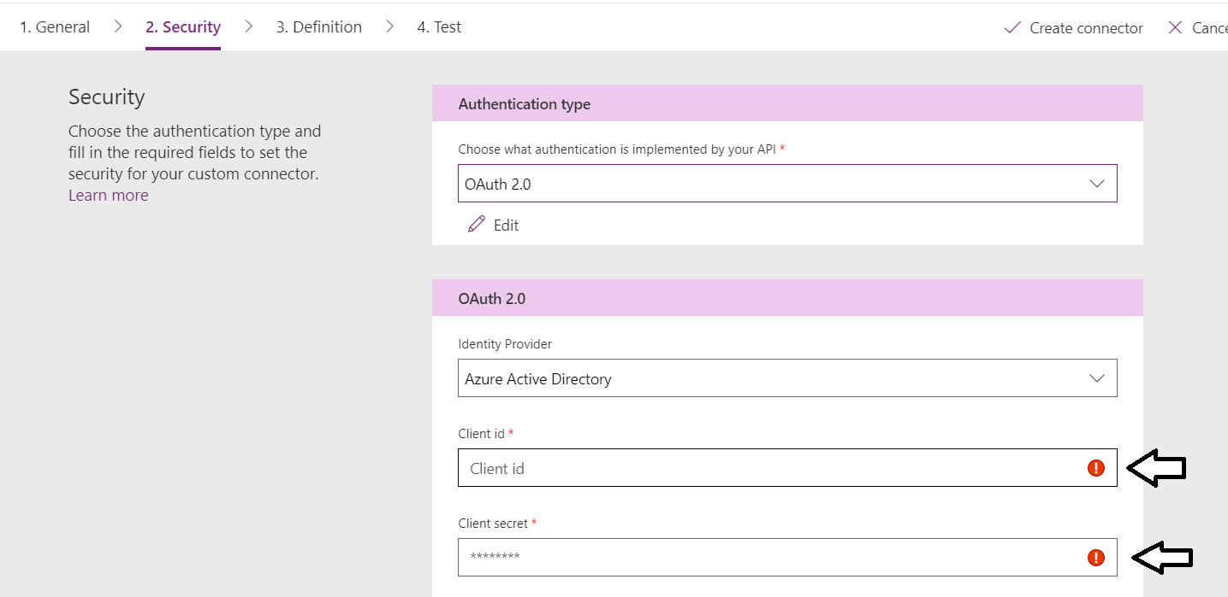

* 1. Fill in the **Client Id** and the **Client secret** values with the **Application ID** and the **Application Secret** values from Notepad.

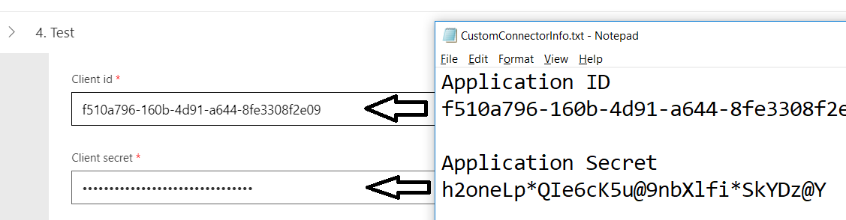

* 1. Enter a value for the **Resource URL** of **https://analysis.windows.net/powerbi/api**.

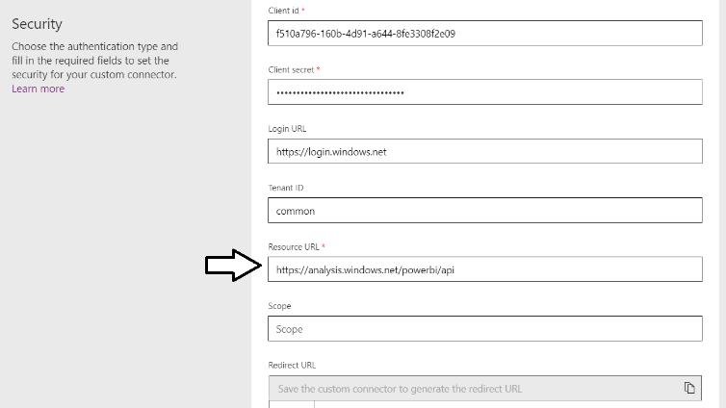

You can leave all the other textboxes in their default vaues.

* 1. Click **Create connector**.

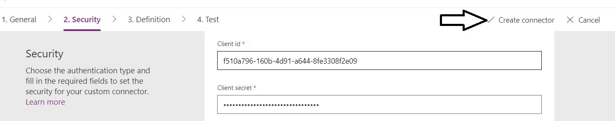

* 1. Once the connector has been created, copy the Redirect URL from the bottom of the **Security** tab.

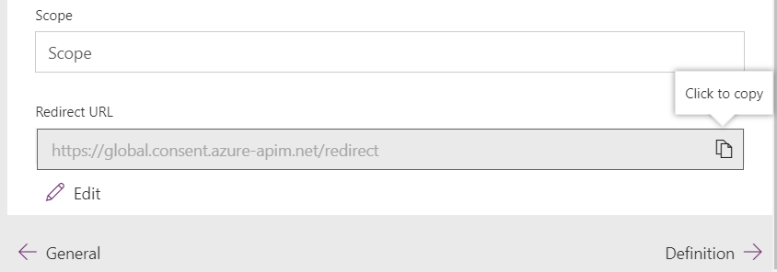

As a final step, you must take the Redirect URL value and REDIRECT URI vale fo the Azure AD application.

* 1. Return to the Azure portal and **Authentication** view for the Azure AD application named **Custom Connector for Power BI**.
  2. Locate the **REDIRECT URI** textbox and add your cursor inside.

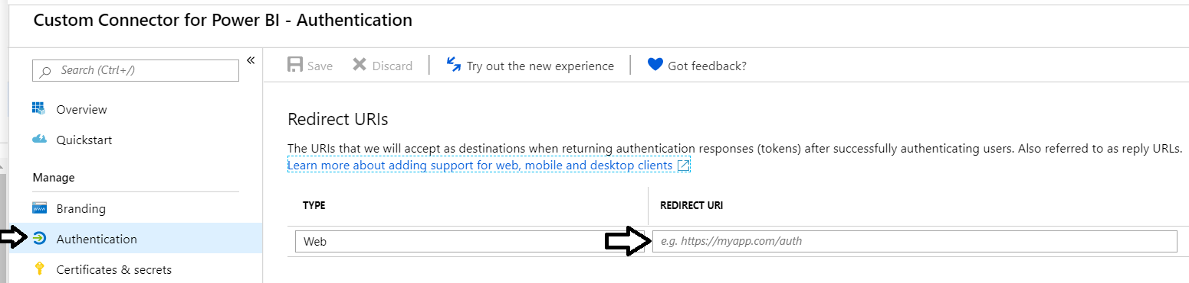

* 1. Paste in the Redirect URL you coped from the PowerApps custom connector and then click **Save**.

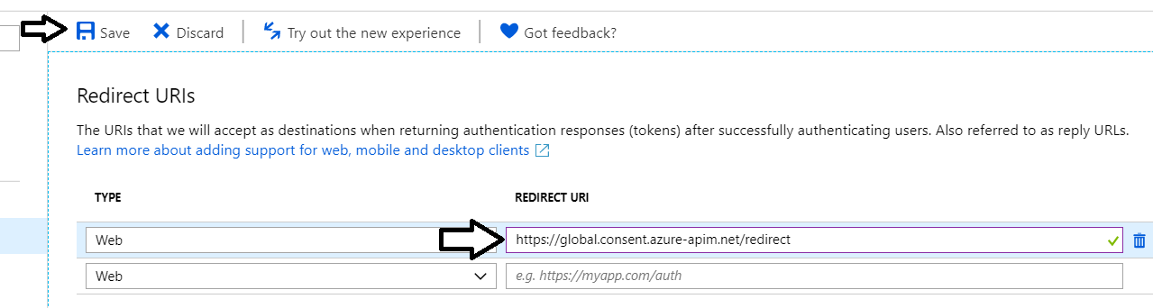

1. Create a new connection for the new custom connector.
   1. Move back to the browser tab with the custom connector and navigate to the **Test** tab.
   2. Click the **New connection** link.

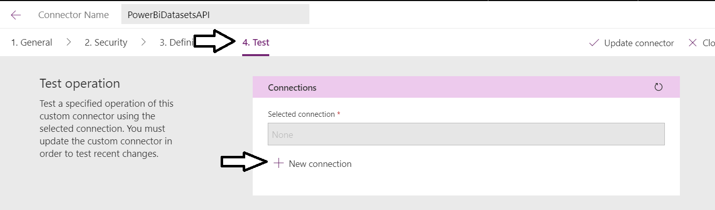

* 1. Click **Create** to create the new connection.

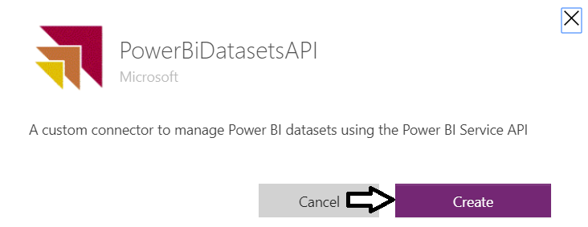

* 1. When prompted, log in with the same account you have been using.

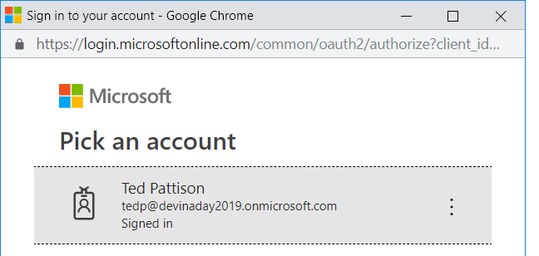

* 1. When prompted to consent to **Permissions requested**, click **Accept**.

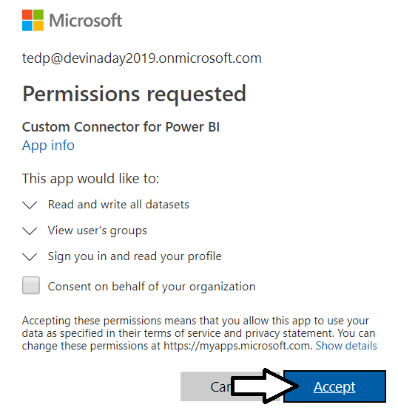

* 1. You should see that the new connection has been created.

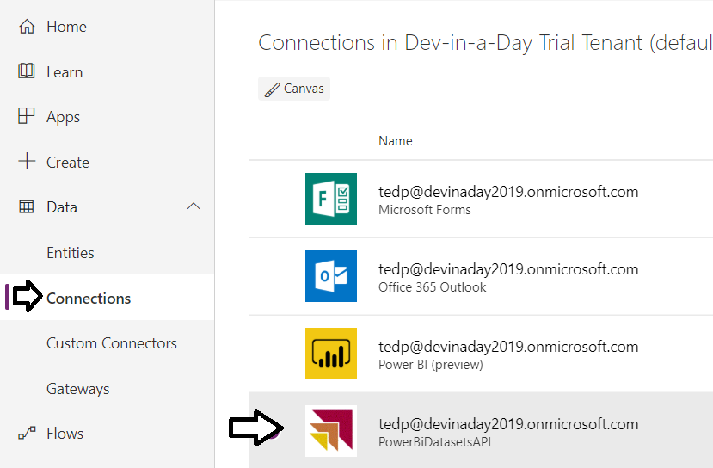

1. Import a canvas app to use the custom connector.
   1. Navigate to the Apps view of the PowerApps Maker portal.
   2. Click **Import package**.

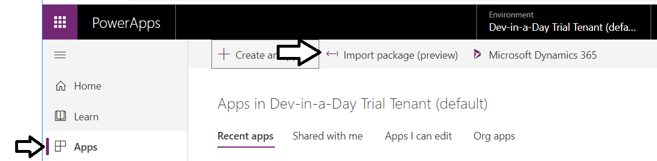

* 1. Click **Upload**.

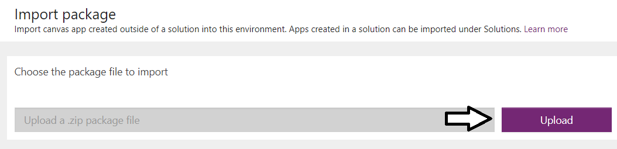

* 1. Select the file from the ZIP archive download named **PowerBIDatasetManager** and click **Open**.

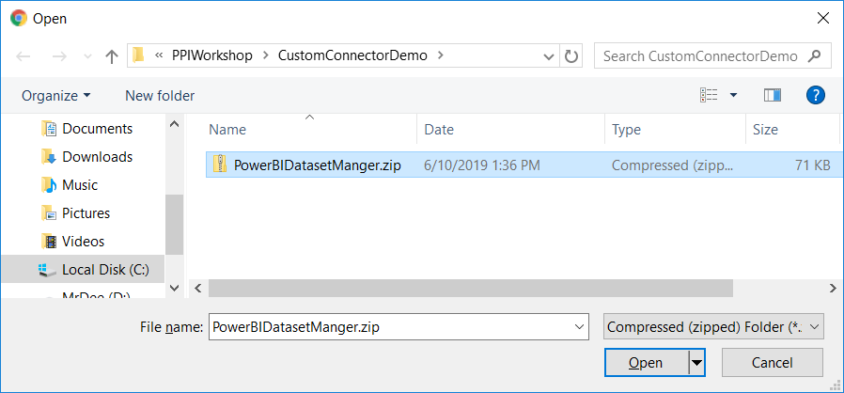

* 1. In the **Related resources** section, click Action for the **PowerBiDatasetAPI**.

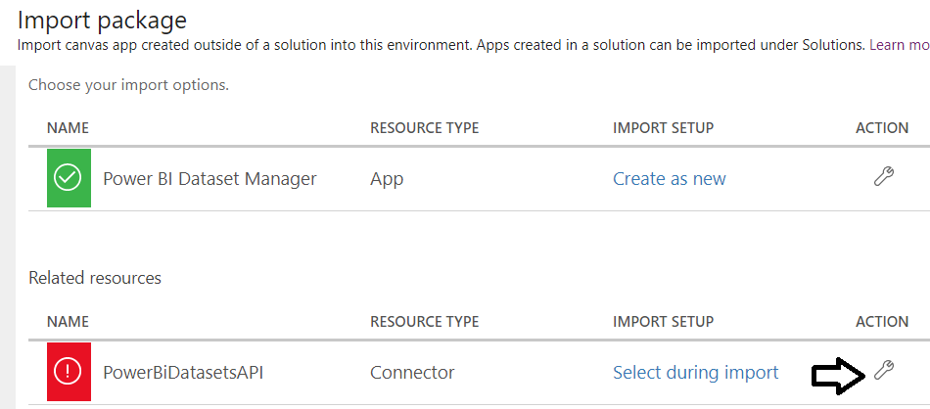

* 1. In the Setup pane, select **PowerBiDatasetAPI** and then click **Save**.

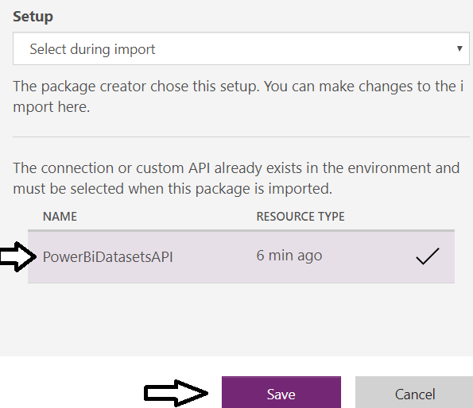

* 1. Click **Import** to import the new canvas app.

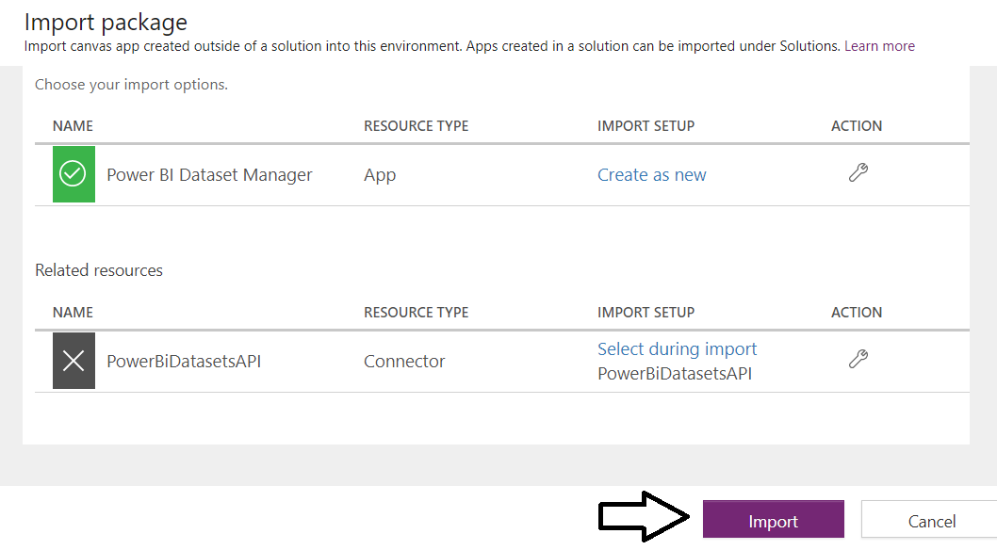

* 1. Open the app in edit mode.

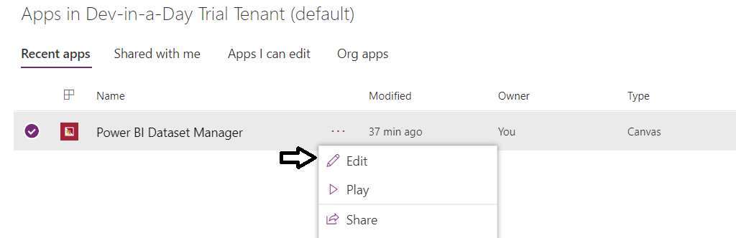

* 1. If prompted for consent, click **Allow**.

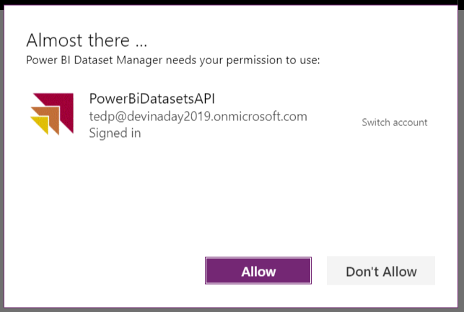

* 1. The app should populate the **WorkspaceScreen** with the Power BI app workspaces in your tenant.

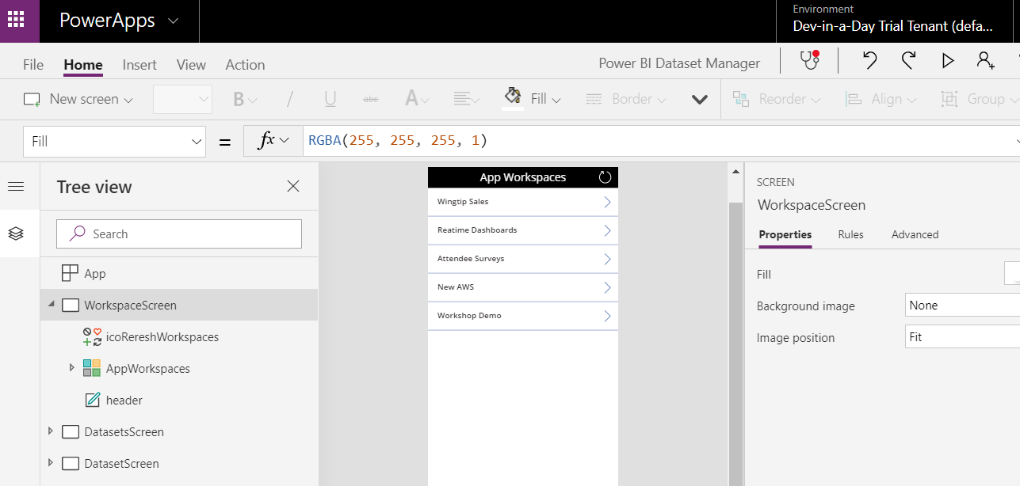

* 1. Start up the canvas app and navigate to a workspace.

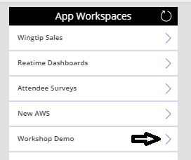

* 1. Click on one of the datasets in that workspace.

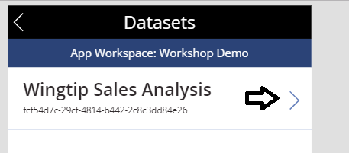

* 1. Inspect the dataset details and try to refresh the dataset

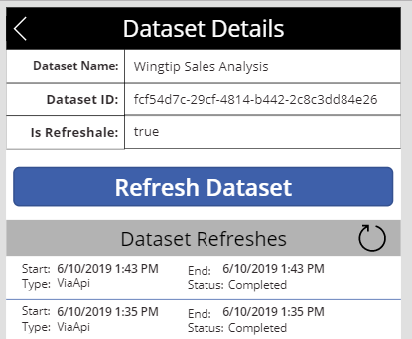

Play around with the canvas app and explore how it uses the custom connector..